BOT ID password renewal process

Author: Santhana Krishnan S
Email id: santhanakrishnans@hpe.com
Team: Global Ops Automation COE

Please note this document is applicable only for Global Ops only. For other business org the support contact is different and it’s not Global Ops Automation COE. Otherwise the BOT ID password change process remains same.

BOT ID – Likewise an Employee has an Identify, BOTs also have an identity with Email ID and Employee ID associated and will used by BOT to login to applications.

But BOT ID uses Class B certificate to login to most of the IT applications instead UN and password. Hence Class B certificate need to be created upon new BOT ID creation and BOT ID password change. If your BOT project applications does not uses Class B then it is not required.

Apart from BOT ID password expiration, there is also BOT ID ACCOUNT expiration, which requires renewal or extend validity of BOT ID account every year, as the BOT ID account has the validity of only 1 year. Follow the process provided @ page 19 of this document to extend the expiration or validity of BOT ID ACCOUNT.

To summarize:
BOT ID password & Class B – expires after 1 year (as per new passphrase policy)
BOT ID account – expires after 1 year

Who creates the BOT ID? - It will be done by CoE

- COE will create the BOT ID -> Request NT account -> Email box -> Reset initial password
- COE will create a secret vault entry for BOT ID (and store username and password) – Secret vault is password storage vault by WorkFusion

Who changes password for BOT ID every 365 days? – It will be done by Ops

- COE will transfer the ownership to Ops and Ops need to maintain the renewals of BOT ID and Class B every 365 days
- BOT ID - new password will need to be reset - https://domain-services.corp.hpecorp.net/ResetDomainPassword/ - PLEASE DO NOT SHARE THE PASSWORD TO DEVELOPERS. BOT ID owner is sole responsible for BOT ID actions.
- Class B – Re-creation of Class B will need to be done https://mydigitalbadge.hpe.com/hpe/hpe_int_menu.html

Note: BOT ID application access credential will not impact with this renewals

Please see password input procedures document which need to be followed by BOT ID owner

Who updates the password & re-install Class B? – Own by Ops and request to CoE

- Ops to reach out to COE (Krishnan) to update the new BOT ID password in secret vault
- Ops to reach out to COE (Krishnan) to re-install Class B certificates in Production Server
- Ops to reach out to COE (Krishnan) to re-install Class B certificates in Development Server. Re-installation in Dev server to be done only when it’s required.
- BOT ID Class B certificate should not be installed in Developers local machine. Instead Developers Class B to be used for app functionality testing in local.
- Node need to be restarted once Class B is re-installed to take effect. Ops to Request COE.
Expiration cycle

BOT ID - 365 days from password reset date.
Class B - 1 year

How do I know when my BOT ID password is expiring?
  - When BOT ID owner change the password he/she has to keep a reminder in your outlook – For a date 2 weeks before the expiration to be prepared for changing BOT ID password & re-creating Class B
  - Set up a rule in BOT ID email box outlook to Forward all emails in BOT ID email inbox to BOT ID owner (Look for password change reminder email)

Please note BOT ID owner should plan for a down time for their BOT, to change Password & Re-install Class B in production server.
How do I change the BOT ID password?

Password renewal link - https://domain-services.corp.hpecorp.net/ResetDomainPassword/
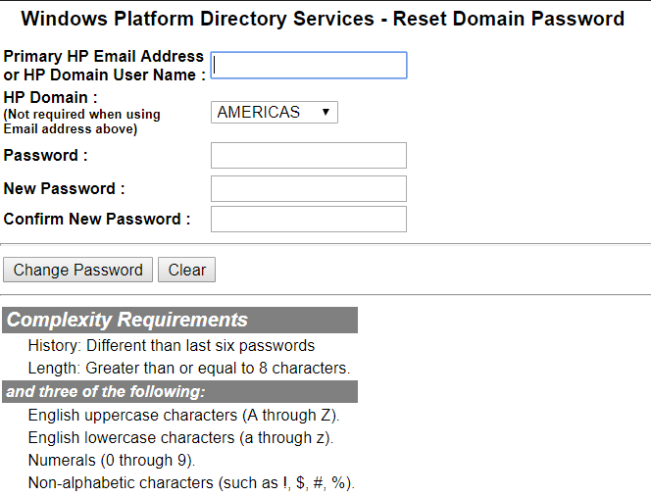
- Enter the BOT ID email address
- Enter the current password
- Enter the new password
- Re-Confirm the new password
- Click Change password
- Request COE to update new password in Secret Vault

Important note: There could be failures in changing the password like below, hence it’s suggested to perform the password reset 1 week in advance.

If you receive such error, submit an IT ticket via IT Helpdesk Call or Chat and explain the problem. On IT failing to resolve the error or don’t have answer, IT would suggest to reset the password. Please go ahead and do that, and you (BOT owner) will receive a password in your email box which will be sent by IT. And you will be able to use or change the provided password by IT only after 24 hours. We suggest you to change the password provided by IT and then create Class B. Hence please note you may have a downtime of 24 hours of your BOT here. As your existing Class B will expire in server once you reset the password.

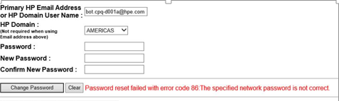

How do I re-create Class B Certificate?

Class B renewal link - https://mydigitalbadge.hpe.com/hpe/hpe_int_menu.html
Follow the instructions in the attachment
- It is recommended to renew Class B in Mozilla Firefox browser Incognito mode (private window)
As this will avoid picking any other user credential login and allow you to enter only user name & password
- To open Private window - Click on CTRL + SHIFT + P

Please use only Mozilla Firefox version 68.0 for this activity. Other versions won’t help on Class B renewal.

Steps to install Firefox 68.0

  - Uninstall current version of Firefox
  - Download the Firefox version 68.0
  - Switch off the WiFi and/or remove LAN from your laptop to disconnect the internet
  - Install the Firefox version 68.0
  - Open Firefox and Go to settings of the Firefox
  - Search for “Updates”
  - In “Allow Firefox” Select “Check for updates but let you choose to install them”
  - Do not switch on internet until you complete Step 7 (otherwise the version 68 will get upgraded automatically)

Steps

- Open Firefox
- Press CTRL + SHIFT + DEL and Clear all History
- Close Firefox
- Open Firefox
- Press CTRL + SHIFT + P to open New Private Window
- Login to https://mydigitalbadge.hpe.com/hpe/hpe_int_menu.html and press enter
- Click on "Class B Enrollment"
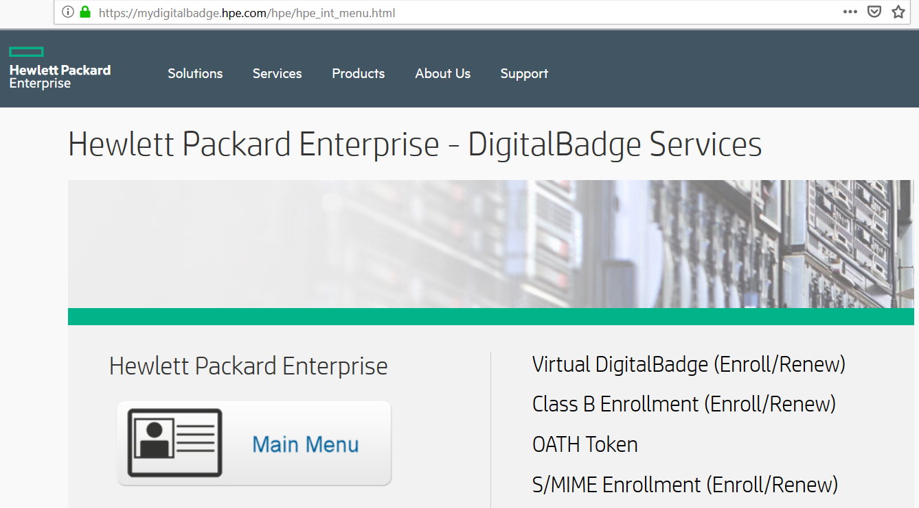

- Enter BOT Email id and password
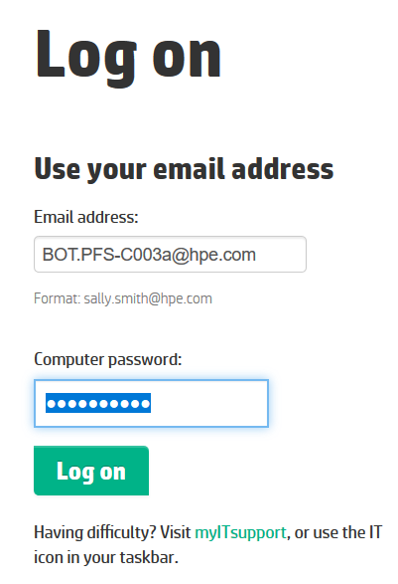
- Click "accept & continue" in "Class B Digital Badge enrollment/renewal"
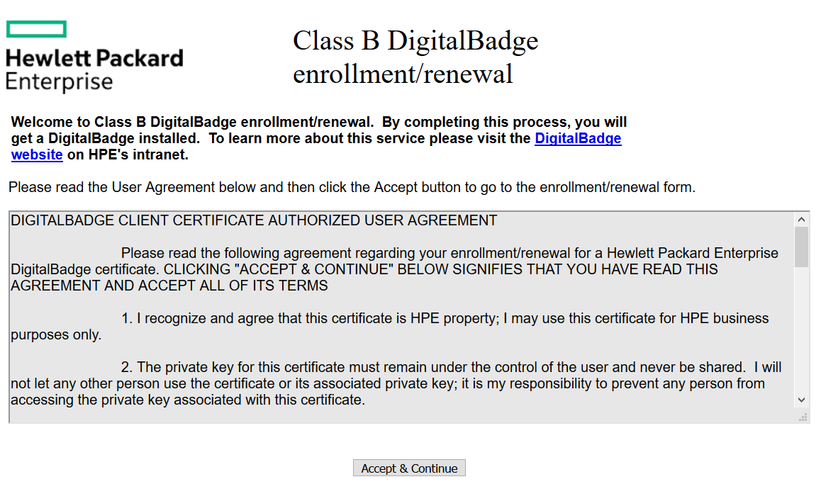

- Click "Click here to Continue with Class B Enrollment" in next screen titled "Class B Digital Badge enrollment/renewal"
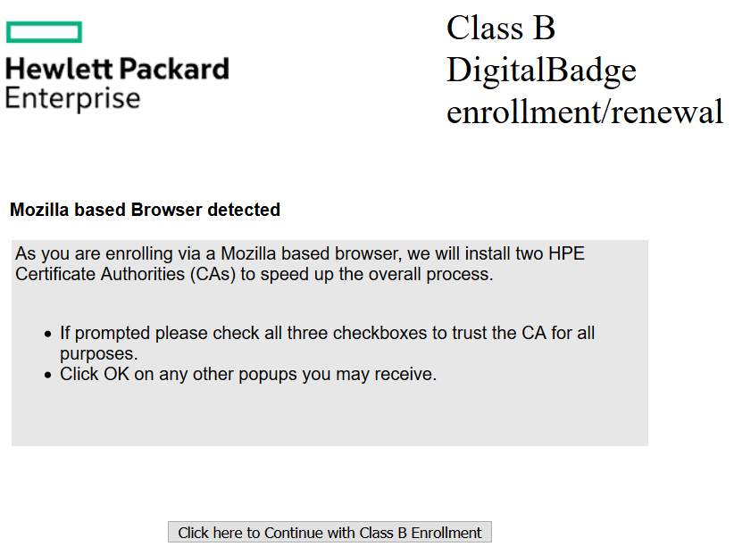
- You get successful message of Class B renewal
Now the certificate is installed in browser, and follow below steps to retrieve from Browser
- Go to browser Options
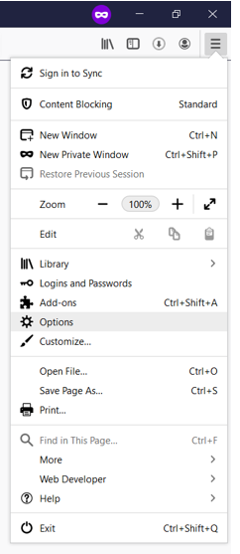
- And Type "Certificates" in Search box

- Click on "View Certificates"

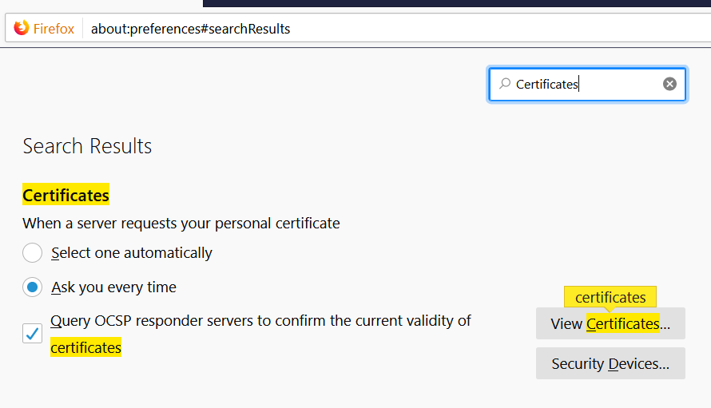
- In "Certificate Manager" dialog box Click on "Your Certificates" tab
- You will find BOT ID listed there
- Select the BOT ID
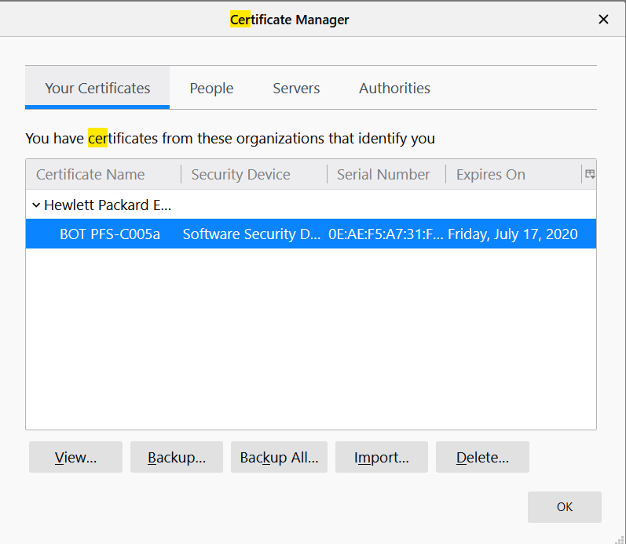
- And click on "Backup" button
- A new dialog box now appears to save the BOT certificate
- You need to save certificate as "PKCS12 Files" - Select this in "Save as type"
- Give a file name to BOT ID certificate
- And click on Save
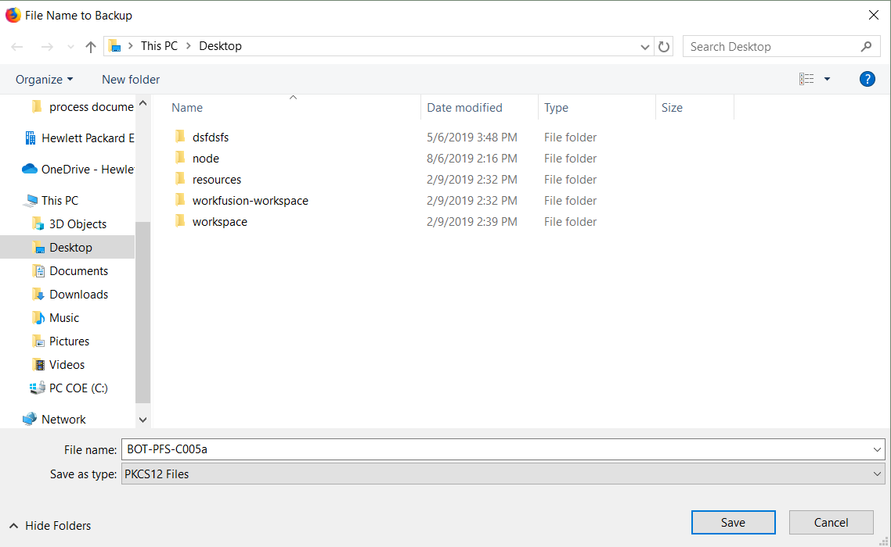
- Now a new dialog box appears to give backup password for BOT ID Certificate
- Provide a 4 or 5 character password
- And Click "OK"
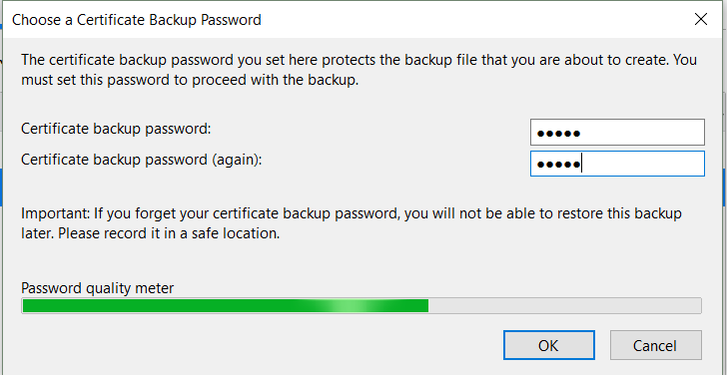
- Now a BOT ID - Class B certificate has been retrieved from Browser
- Next step is to Import/Install this certificate in Server

How do I re-install Class B Certificate?

- Make sure to the remember the folder location or URL, where you have stored the Class b certificate
- Open Chrome
- Type chrome://settings/ in URL
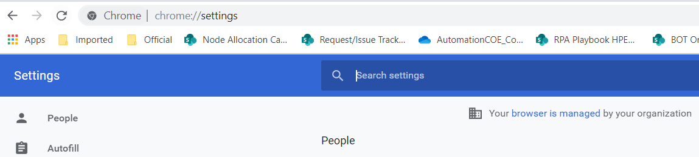
- Type "Certificates" in Setting search bar
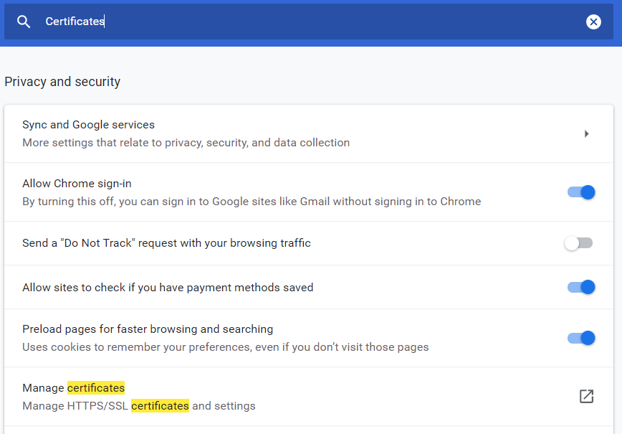

- Select "Manage Certificates" from the result
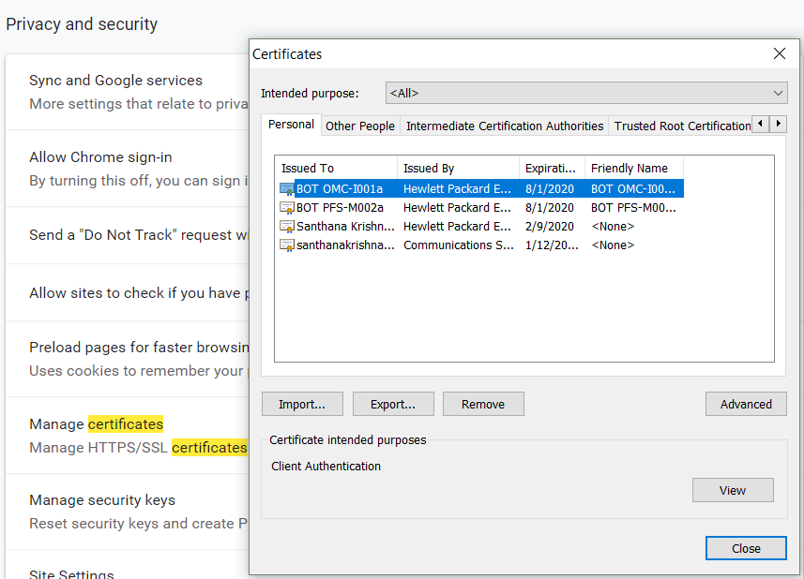
- Click "Import" button in "Certificates" Dialog box
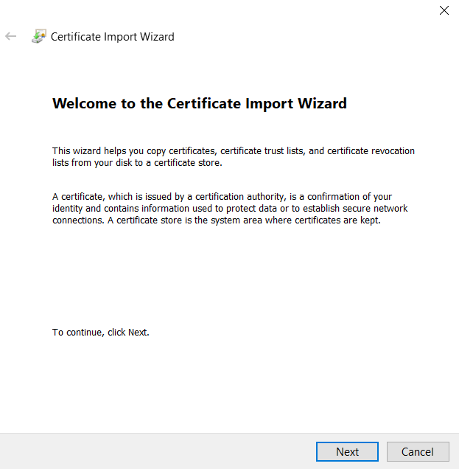
- Click "Next" button in "Certificate Import Wizard"
- In File to import Click "Browse" button
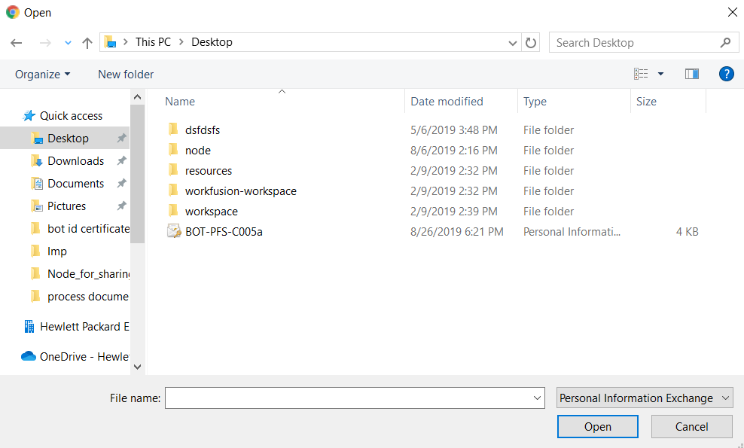
- Locate the Certificate file from your PC
- Select "Personal Information Exchange" as File type
- Select your Certificate
- And Click on "Open" button
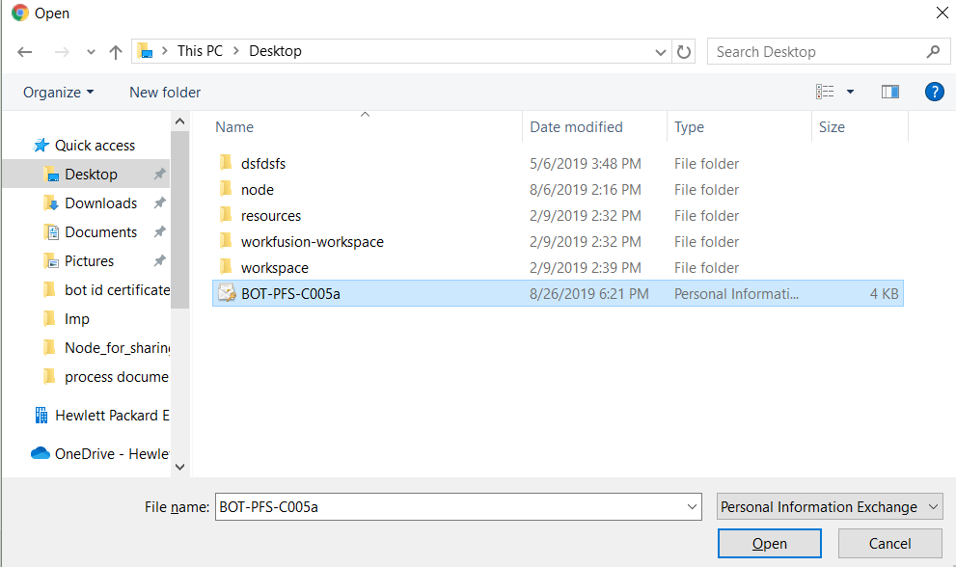

- Click "Next" button
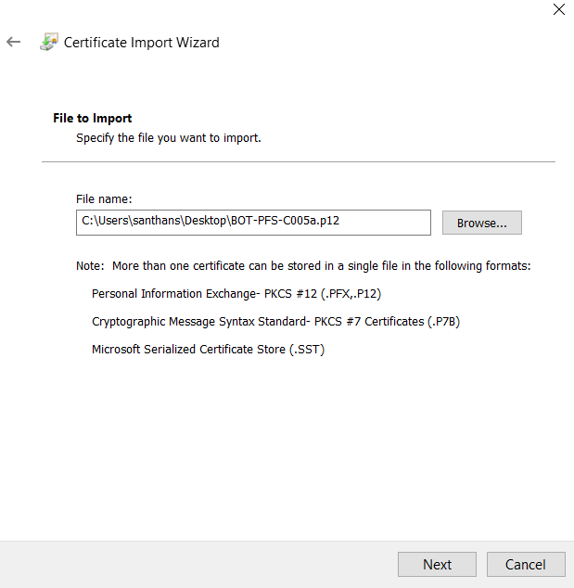
- Enter the private key password (never select show password)
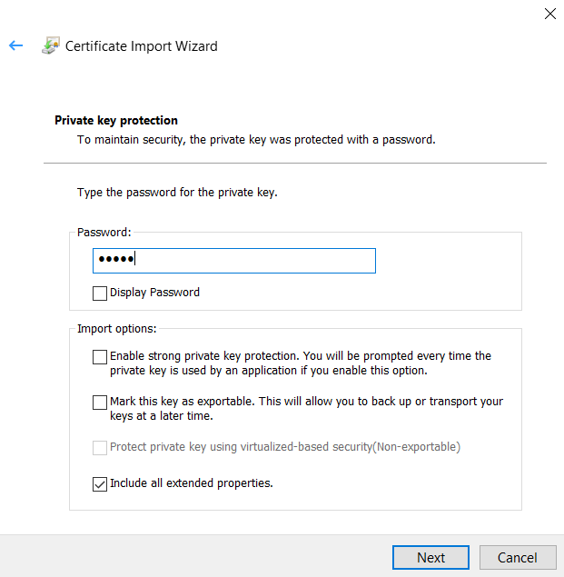
- In import options make sure only "Include all extended properties" is checked
- Click "Next" button
- In "Certificate Store" Select "Place all certificates in the following store"
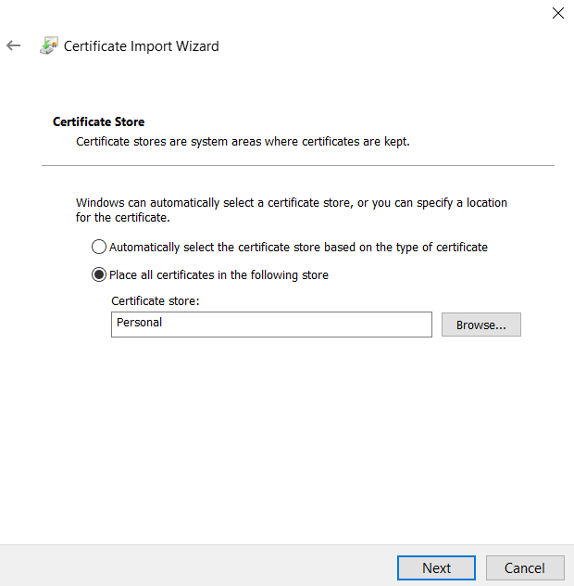
- Make sure "Personal" is selected in "Personal Store" if not Click "Browse" and Select
- Click "Next"
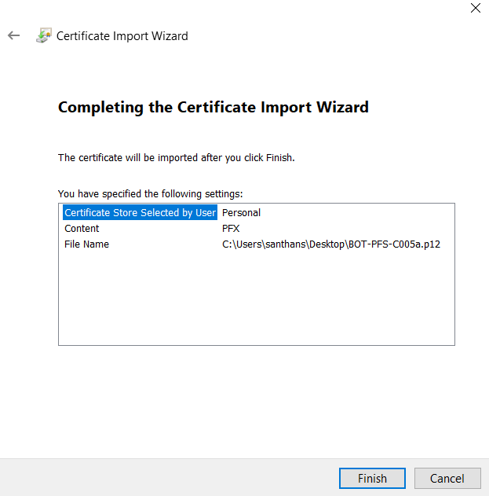
- Click "Finish"

- Click "OK" in "Certificate Import Wizard" where it says "The import was successful"
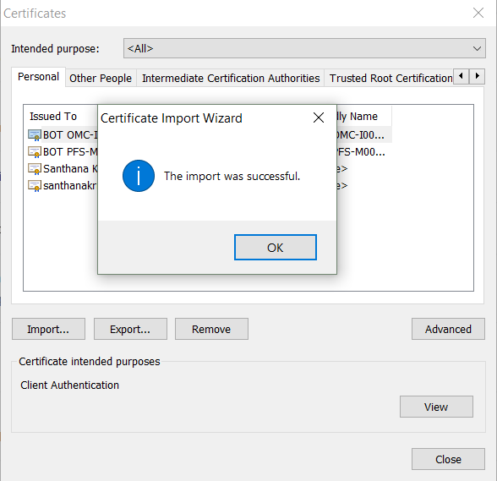
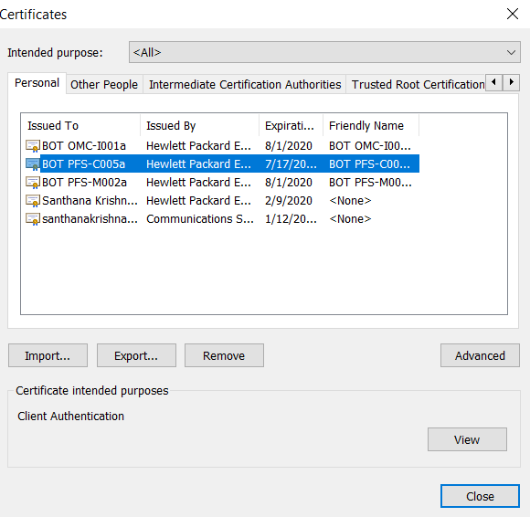

- Now BOT can login using Imported BOT ID Class B certificate by Selecting it

Outlook rule setup in BOT ID email box
It is very important for the BOT ID owners to know what emails are being received in BOT ID email box and required to act on BOT ID password expiration & Application access expiration emails for applications that BOT ID has access to
Rule to forward all BOT ID inbox email to BOT ID owner (To be done by Ops – BOT ID owner)
You can also setup different rule to “redirect” emails only related to password expiry or application access expiry. The rules are settings of Microsoft Outlook and self-served.
- You need to set up the rule in https://outlook.office365.com/
- Before that you need make sure the respective BOT ID – Class B is installed in Firefox browser
(You can only login using Class B as Office 365 is MFA enabled)
- Complete Step 2
- And login to https://outlook.office365.com/ - Mozilla Firefox private window.
- Enter the BOT ID email ID and Select “Next”
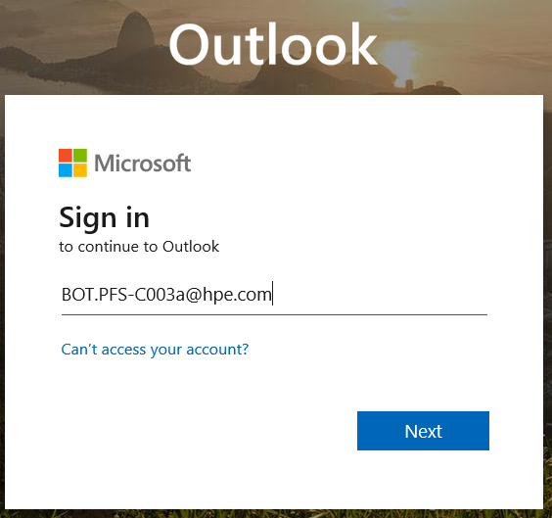
- Select the BOT ID certificate in below dialog box. Uncheck “Remember this decision”
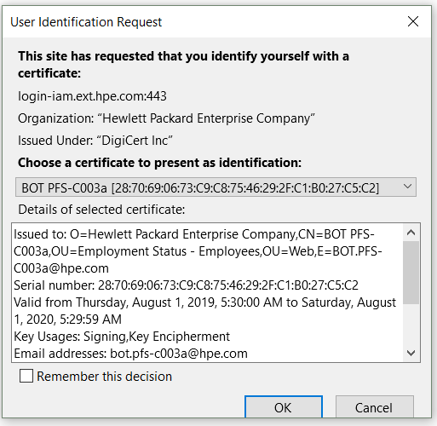
- Click "Ok"
- Web outlook loads
- Click 'Settings" on top right of the page
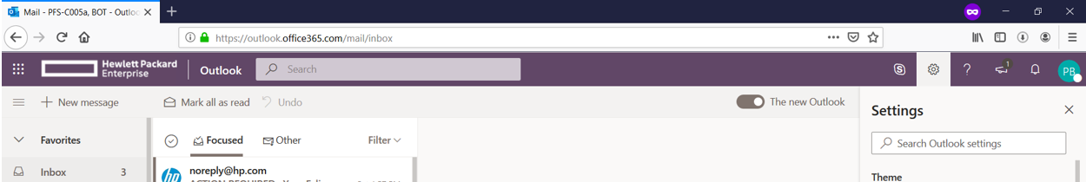

At bottom in pop up pan Click on "View all Outlook Settings"
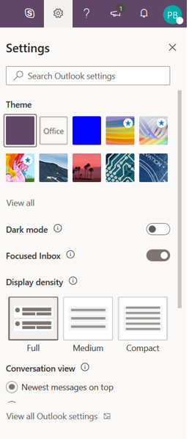
- Click "Rules" in Layout
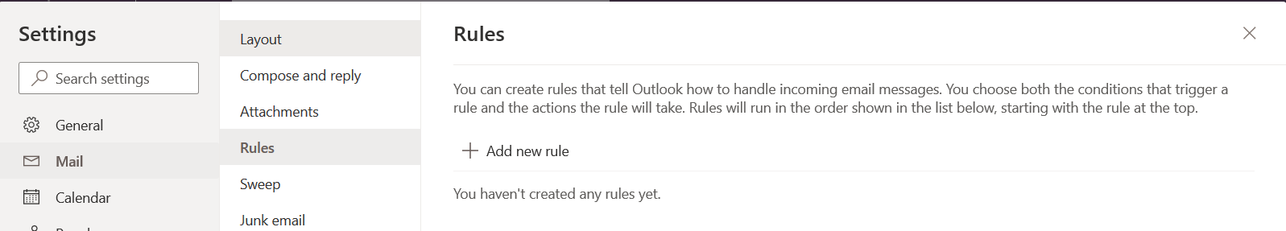
- Click "Add new rule"
- Give a name to the rule example : Forward all emails
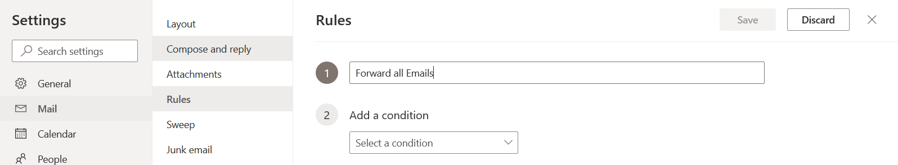
- In "Add Condition" Menu select "Apply to all messages"
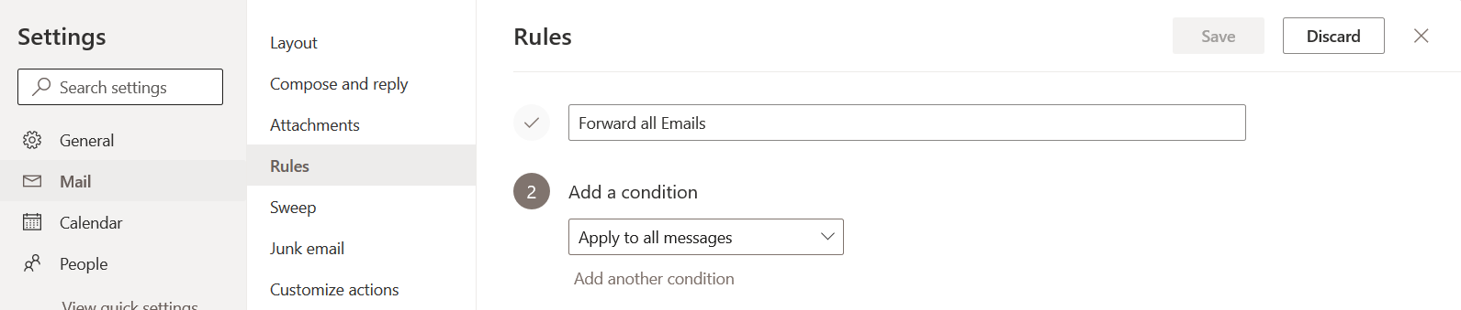

- In "Add an action" select "Forward to" and given BOT ID owner email id
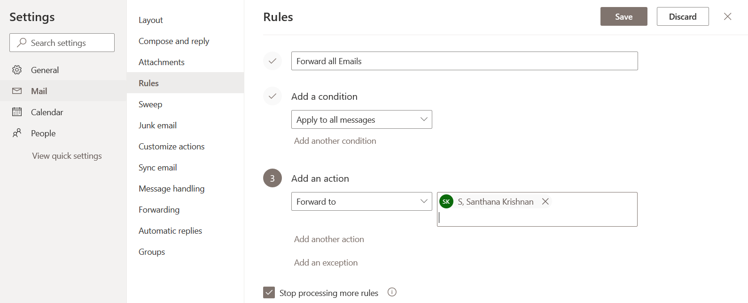
- Leave "Stop processing more rules" as checked
- And "Save" the rules
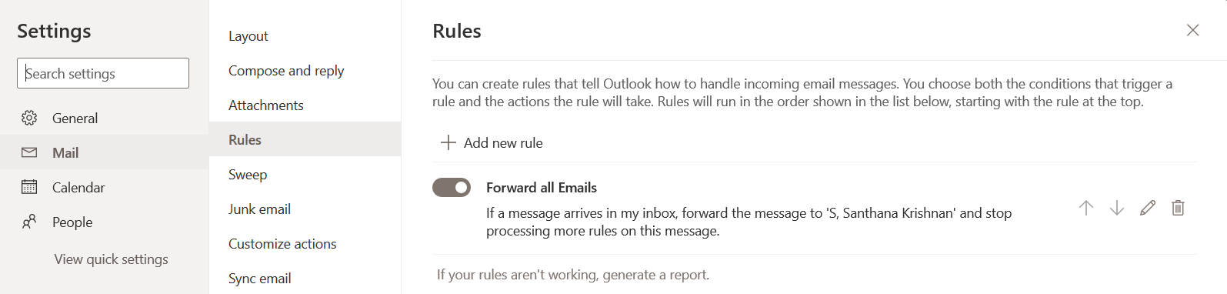
- After this rule is applied all the new emails will be forward to BOT ID owner

BOT ID LOGIN TO OFFICE APPLICATIONS IN NODE:

Please note if your BOT Project uses any of the Office application like excel, then its required to be logged in with BOT ID by the BOT ID owner in Production node during MTP. BOT ID owners can work with COE team to login to Office apps in the nodes where the BOT is running.

Steps attached.

This is to make sure in all nodes office applications are logged in with BOT ID and does not prevent BOT run with any sign in dialog boxes.

Other Key info:

All application access (expiration/renewal) of the BOT ID should have to be maintained by BOT ID owner.

BOT ID ACCOUNT expiration and Validity extension process

- BOT ID ACCOUNT has validity of 1 year.
- You need to request IT to extend the expiration of BOT ID ACCOUNT (new expiry date should be 1 year from date of request to IT)
- To extend the expiration of BOT ID account - Raise an IT ticket using IT Helpdesk (Chat or Call). Request to extend the expiration of BOT ID account for the next one year. And repeat ever year before the expiration.
- Please raise IT ticket 2 weeks in advance. (2 weeks before the expiration)
- Please mention below points when you are raising ticket with IT
  - I would like to extend the expiration date of my BOT ID ACCOUNT BOT.XXX.XXXXX@hpe.com Employee ID : 99xxxxxx for next 1 year
  - Please assign this ticket to DXC DIRECTORY OPERATIONS team where the Queue is W-INCLV3-DC-DS. Please provide this past IM ticket # IM29897455 as reference and also mention this ticket is for Wade Durdin’s team.
Note: Please take a note of new expiration date, as you will not be able to check that in ATM or any other portal. If you want to know the expiration date, please raise a ticket with IT Helpdesk (Chat or Call).

Supportive documents

Document update log

Serial # | Updated Item | Updated Date | Updated By
1. | Password input procedures for BOT ID owner | 11-Dec-2019 | Santhana Krishnan S
2. | Added point on application access in “Other Key info” section | 09-Jan-2020 | Santhana Krishnan S
3. | Updated steps to install Firefox version 68.0 | 3-Mar-2020 | Santhana Krishnan S
4. | BOT ID Account expiration & Validity extension process | 8-Jun-2020 | Santhana Krishnan S
5. | Update the process to be followed when there is error in changing password in password reset portal | 8-Jun-2020 | Santhana Krishnan S
6. | BOT Login to Office applications in Node | 3-Mar-2021 | Santhana Krishnan S
7. | BOT IT password change frequency updated from 90 days to 365 days as per new passphrase policy | 13-Jul-2023 | Santhana Krishnan S

